Lab 9

1. What is the shortest path between DR. STRANGE and DR. DOOM?

Code:

**MATCH** p**=(**peter**:**Hero **{**name**:** 'DR. STRANGE/STEPHEN'**})-[:**APPEARED**\***0..2**]-(**logan**:**Hero **{**name**:** 'DR. DOOM/VICTOR VON'**})**

**RETURN** p**,** **length(**p**)**

**ORDER** **BY** **length(**p**)**

**LIMIT** 1

Graph:

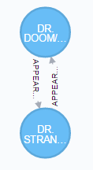

Shortest Path:

DR. STRANGE <-> DR. DOOM (Distance: 1)

1. List the 5 shortest paths between DR. STRANGE and DR. DOOM

Code:

**MATCH** p**=(**strange **:**Hero **{**name**:** 'DR. STRANGE/STEPHEN'**})-[**APPEARED**\***0..2**]-(**doom**:**Hero **{**name**:** 'DR. DOOM/VICTOR VON'**})**

**RETURN** p**,** **length(**p**)**

**ORDER** **BY** **length(**p**)**

**LIMIT** 5

Graph:

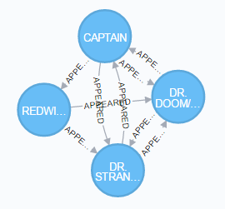

5 Shortest Paths:

DR. STRANGE <-> DR. DOOM (Distance: 1)

DR. STRANGE <-> CAPTAIN BRITAIN <-> DR. DOOM (Distance: 2)

DR. STRANGE <- REDWING -> DR. DOOM (Distance: 2)

1. List 5 Friends of Friends with the most connections and COLOSSUS II.

Code:

**MATCH** **(**colossus**:**Hero **{** name**:** 'COLOSSUS II/PETER RA' **})-[:**APPEARED**\***2**]-(**friend_of_friend**)**

**WHERE** **NOT** **(**colossus**)-[:**APPEARED**]-(**friend_of_friend**)**

**AND** friend_of_friend**.**name **<>** 'COLOSSUS II/PETER RA'

**RETURN** friend_of_friend**.**name**,** **COUNT(*)**

**ORDER** **BY** **COUNT(*)** **DESC** **,** friend_of_friend**.**name

**LIMIT** 5

Results:

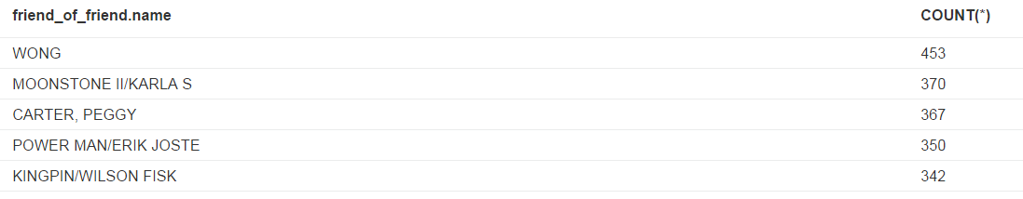

1. Visualize 10 Friends of friends for IRON MAN

Code:

**MATCH** **(**tony**:**Hero **{** name**:** 'IRON MAN/TONY STARK' **})-[:**APPEARED**\***2**]-(**friend_of_friend**)**

**WHERE** **NOT** **(**tony**)-[:**APPEARED**]-(**friend_of_friend**)**

**AND** friend_of_friend**.**name **<>** 'IRON MAN/TONY STARK'

**RETURN** friend_of_friend

**LIMIT** 10

Graph:

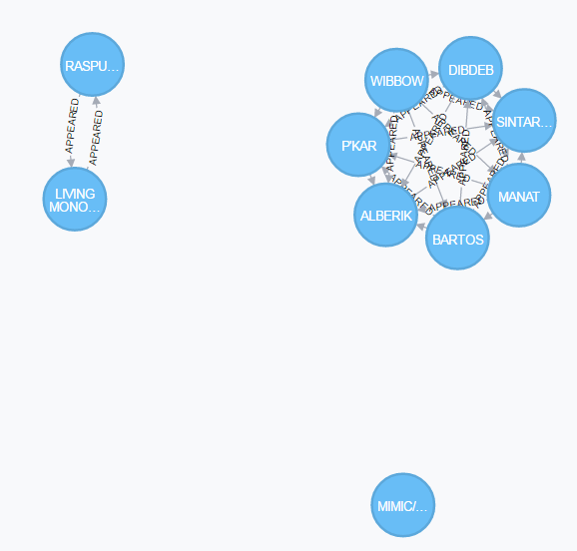

1. Discover how the Avengers grew over time from 5 to 10. Find team members starting with 5 and incrementing to 10. Who was added to the team? Is the resulting graph ever not fully connected?

* Starting members include: 'IRON MAN/TONY STARK', 'THOR/DR. DONALD BLAK', 'ANT-MAN/DR. HENRY J.', 'WASP/JANET VAN DYNE', 'HULK/DR. ROBERT BRUC'

Code:

**MATCH** **(**hero**:**Hero**)**

**WHERE** hero**.**name **IN** **[**'IRON MAN/TONY STARK'**,** 'THOR/DR. DONALD BLAK'**,** 'ANT-MAN/DR. HENRY J.'**,** 'WASP/JANET VAN DYNE'**,** 'HULK/DR. ROBERT BRUC'**]**

**RETURN** DISTINCT hero

Graph:

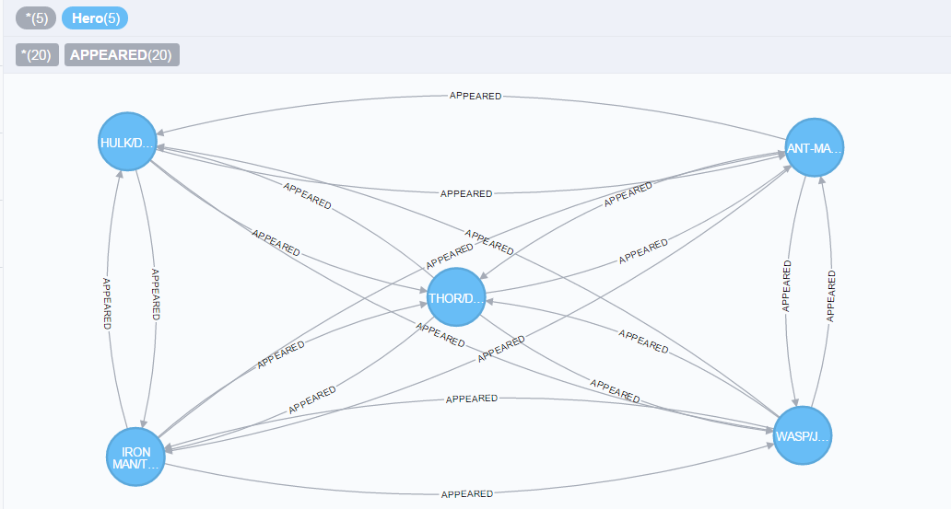

They are fully connected since there are 20 relationships among them.

* Then Captain America Joins.

Code:

**MATCH** **(**hero**:**Hero**)**

**WHERE** hero**.**name **IN** **[**'IRON MAN/TONY STARK'**,** 'THOR/DR. DONALD BLAK'**,** 'ANT-MAN/DR. HENRY J.'**,** 'WASP/JANET VAN DYNE'**,** 'HULK/DR. ROBERT BRUC'**,** 'CAPTAIN AMERICA'**]**

**RETURN** **DISTINCT** hero

Graph:

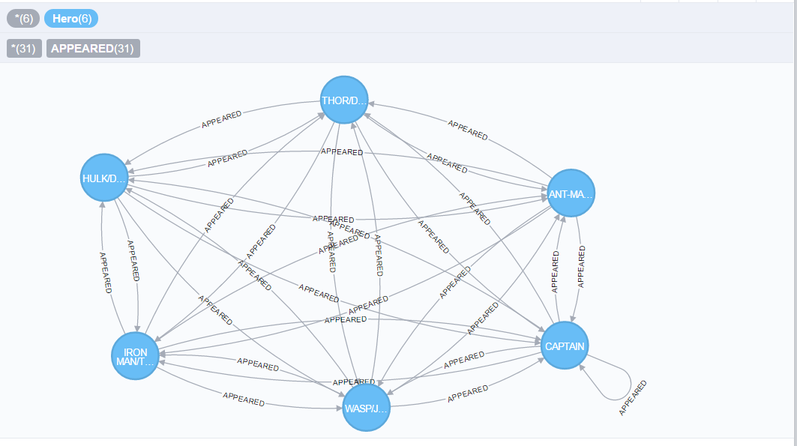

They are fully connected since the relationship among them is bigger than 30. Notice that Captain American connects to himself.

* Then HAWK joins.

Code:

**MATCH** **(**hero**:**Hero**)**

**WHERE** hero**.**name **IN** **[**'IRON MAN/TONY STARK'**,** 'THOR/DR. DONALD BLAK'**,** 'ANT-MAN/DR. HENRY J.'**,** 'WASP/JANET VAN DYNE'**,** 'HULK/DR. ROBERT BRUC'**,** 'CAPTAIN AMERICA'**,** 'HAWK'**]**

**RETURN** **DISTINCT** hero

Graph:

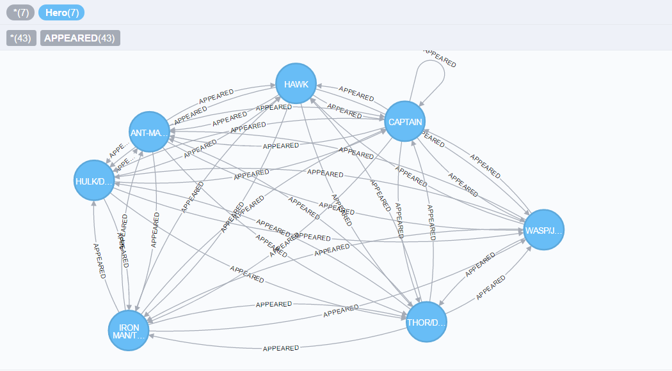

They are fully connected since the relationship among them is bigger than 42.

* Then QUICKSILVER/PIETRO M joins.

Code:

**MATCH** **(**hero**:**Hero**)**

**WHERE** hero**.**name **IN** **[**'IRON MAN/TONY STARK'**,** 'THOR/DR. DONALD BLAK'**,** 'ANT-MAN/DR. HENRY J.'**,** 'WASP/JANET VAN DYNE'**,** 'HULK/DR. ROBERT BRUC'**,** 'CAPTAIN AMERICA'**,** 'HAWK'**,** 'QUICKSILVER/PIETRO M'**]**

**RETURN** **DISTINCT** hero

Graph:

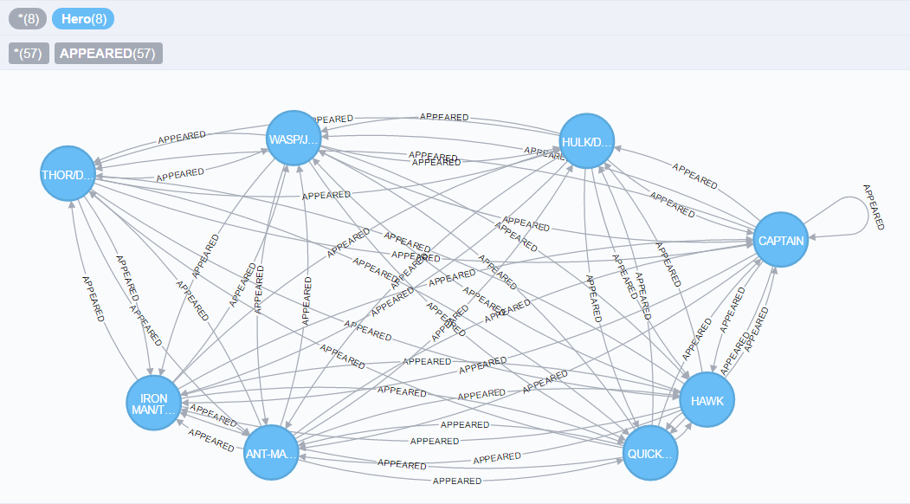

They are fully connected since the relationship among them is bigger than 56.

* Then SCARLET WITCH/WANDA joins.

Code:

**MATCH** **(**hero**:**Hero**)**

**WHERE** hero**.**name **IN** **[**'IRON MAN/TONY STARK'**,** 'THOR/DR. DONALD BLAK'**,** 'ANT-MAN/DR. HENRY J.'**,** 'WASP/JANET VAN DYNE'**,** 'HULK/DR. ROBERT BRUC'**,** 'CAPTAIN AMERICA'**,** 'HAWK'**,** 'QUICKSILVER/PIETRO M'**,** 'SCARLET WITCH/WANDA'**]**

**RETURN** **DISTINCT** hero

Graph:

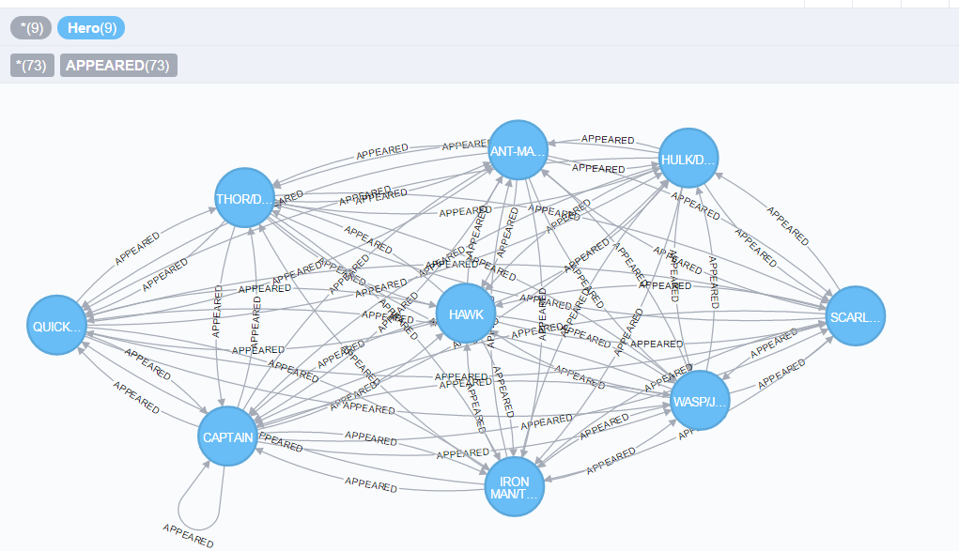

They are fully connected since the relationship among them is bigger than 72.

* Then SWORDSMAN/JACQUES DU joins.

Code:

**MATCH** **(**hero**:**Hero**)**

**WHERE** hero**.**name **IN** **[**'IRON MAN/TONY STARK'**,** 'THOR/DR. DONALD BLAK'**,** 'ANT-MAN/DR. HENRY J.'**,** 'WASP/JANET VAN DYNE'**,** 'HULK/DR. ROBERT BRUC'**,** 'CAPTAIN AMERICA'**,** 'HAWK'**,** 'QUICKSILVER/PIETRO M'**,** 'SCARLET WITCH/WANDA'**,** 'SWORDSMAN/JACQUES DU'**]**

**RETURN** **DISTINCT** hero

Graph:

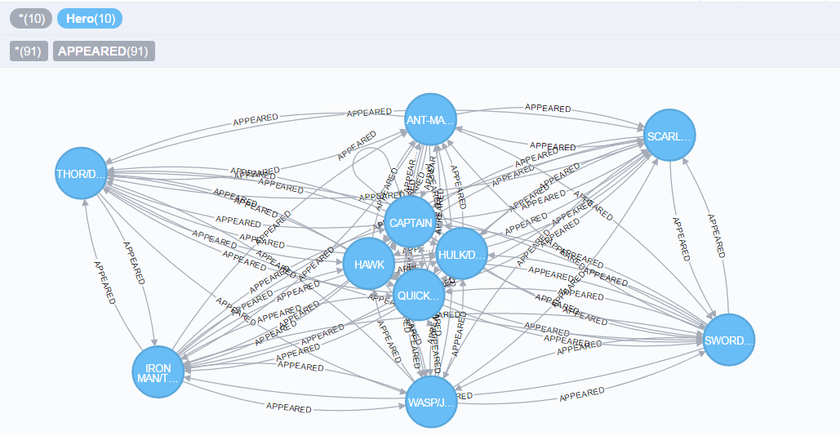

They are still fully connected since the relationship among them is bigger than 90.